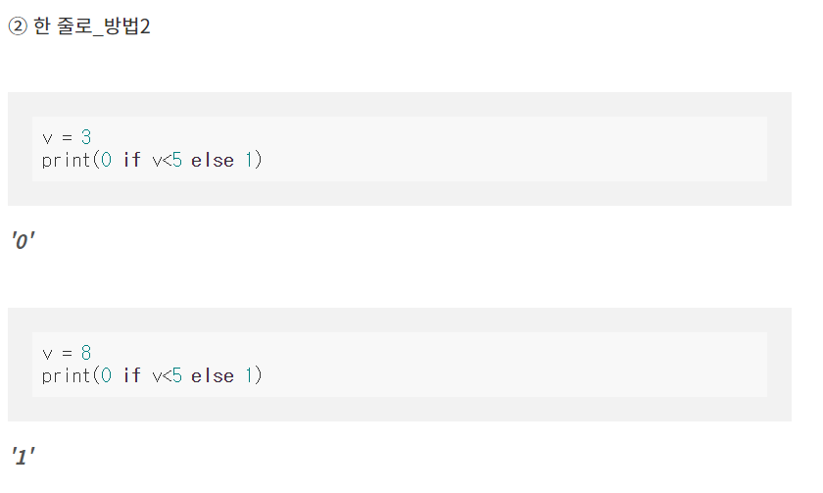

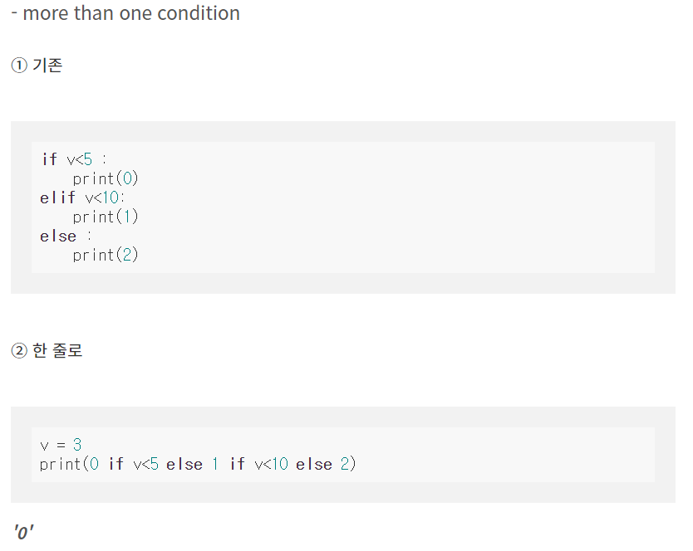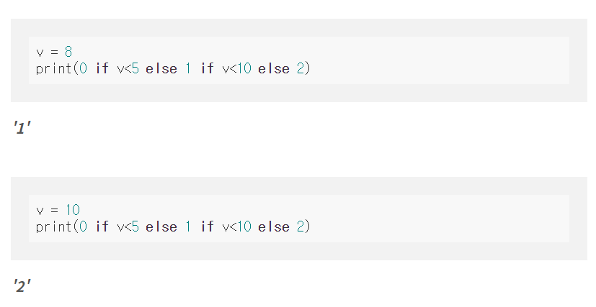

<https://leedakyeong.tistory.com/entry/python-for%EB%AC%B8-if%EB%AC%B8-%ED%95%9C-%EC%A4%84%EB%A1%9C-%EC%BD%94%EB%94%A9%ED%95%98%EA%B8%B0>